# CS 255 System Design Document Template

## UML Diagrams

### UML Use Case Diagram

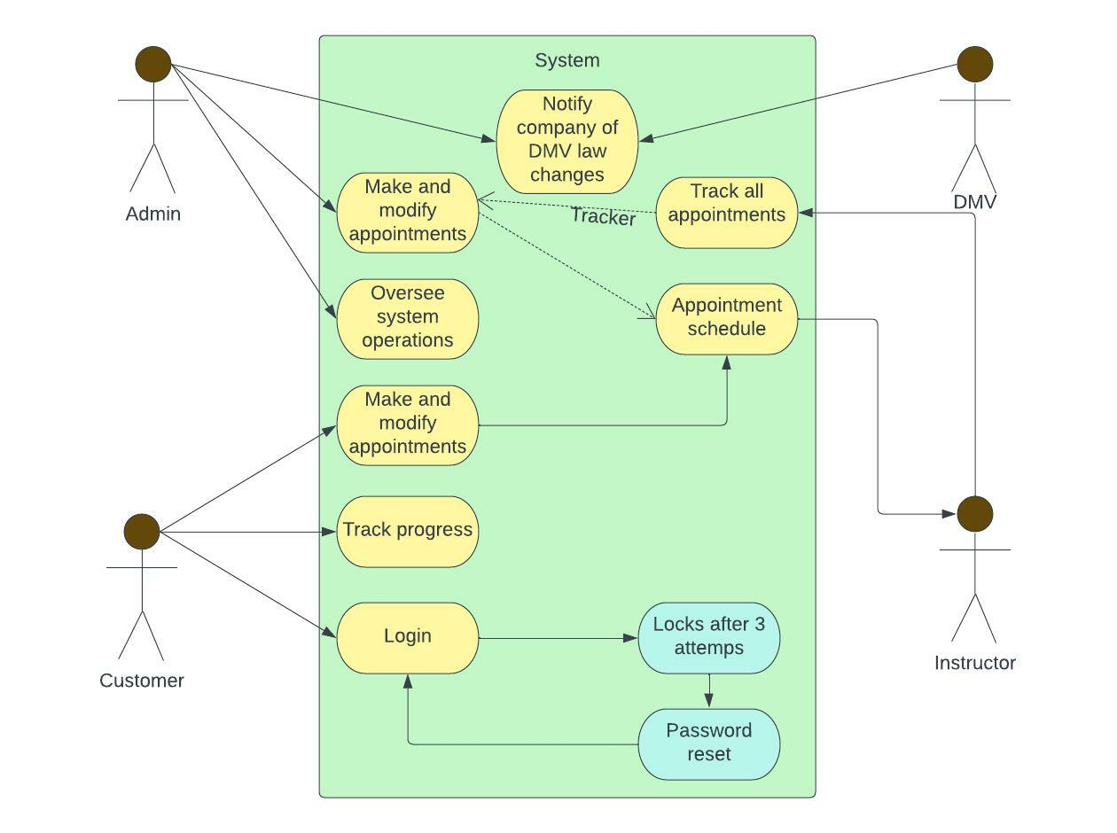

### UML Activity Diagrams

*The first UML activity diagram will display steps for login and creating an account.*

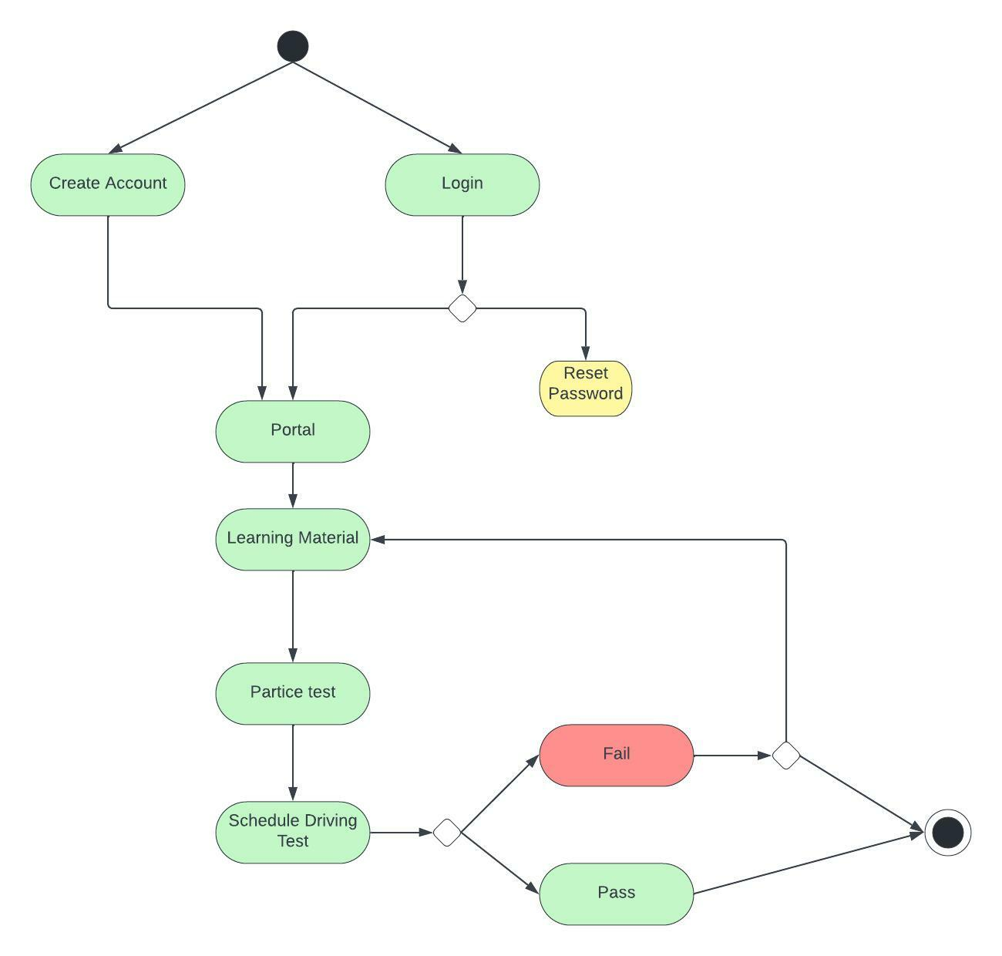

The second UML activity diagram will display steps for managing scheduling within user accounts.

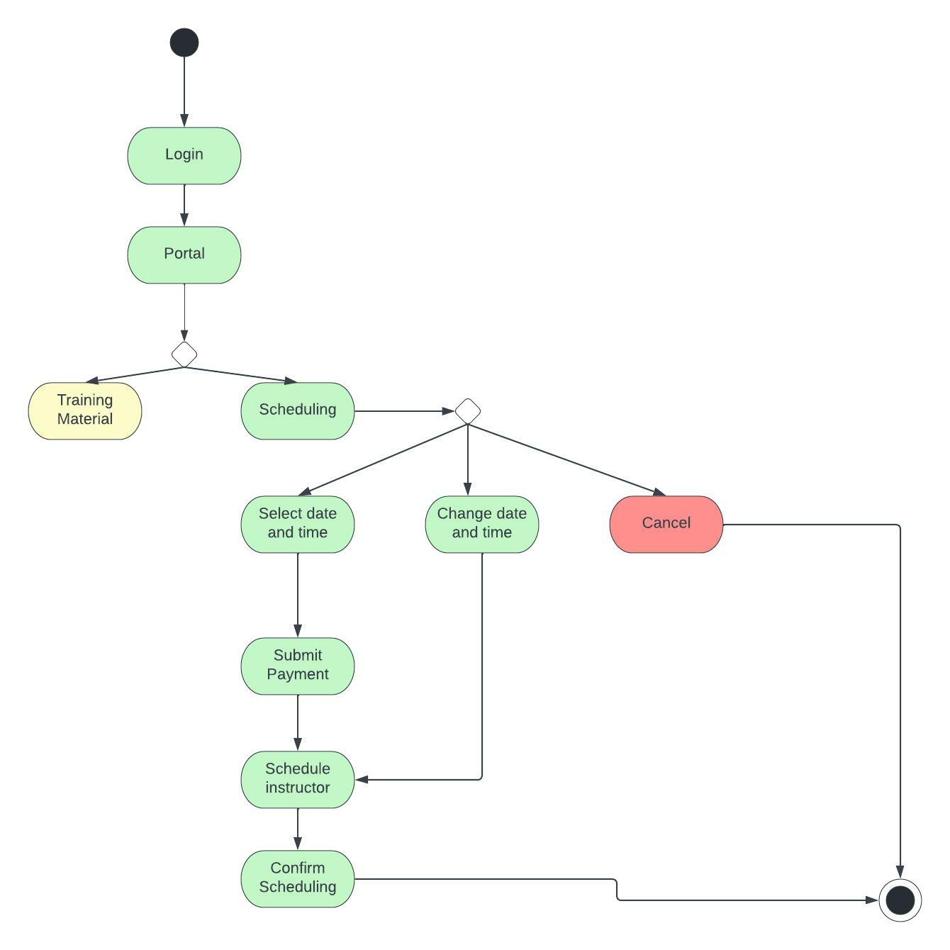

### UML Sequence Diagram

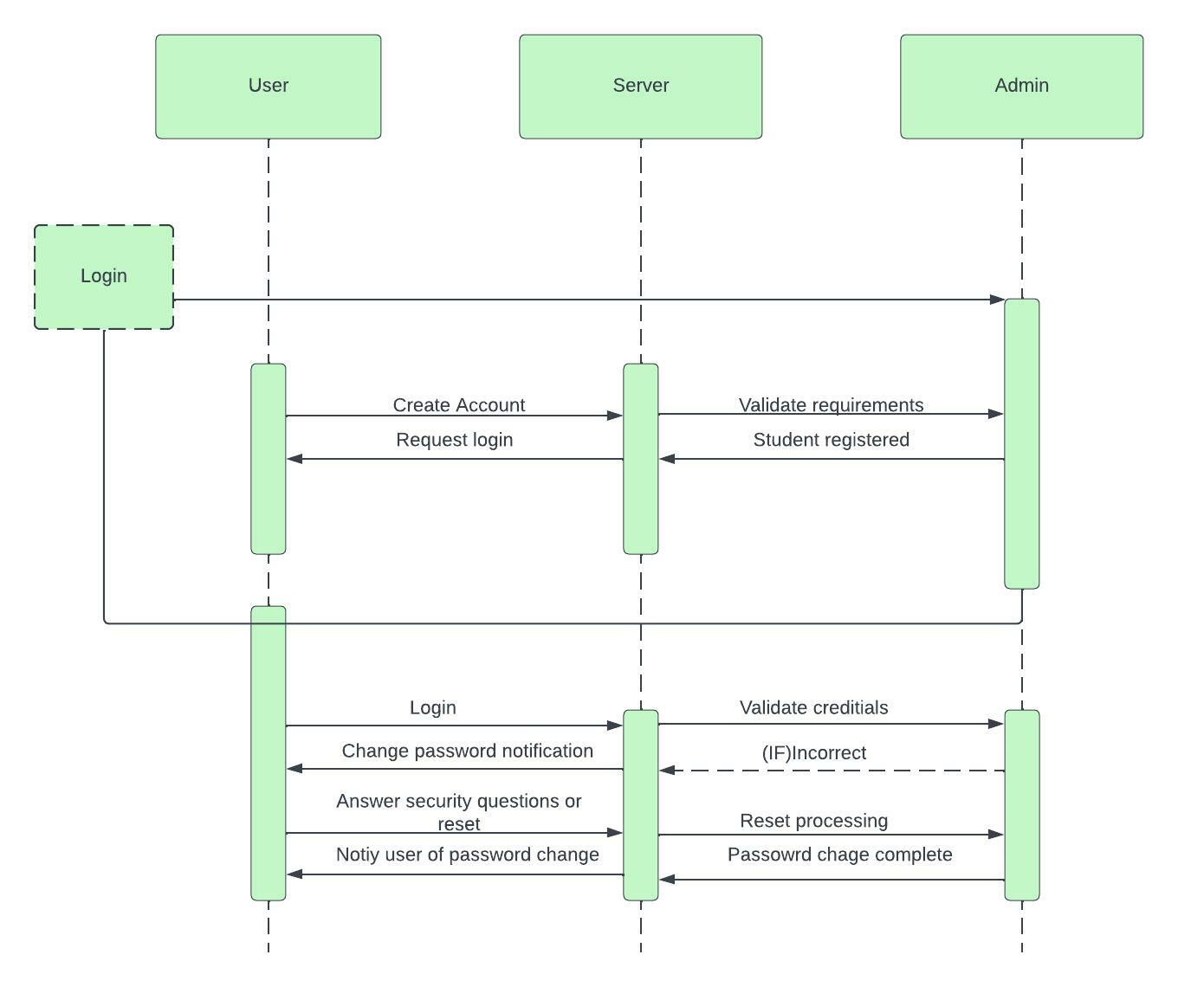

### UML Class Diagram

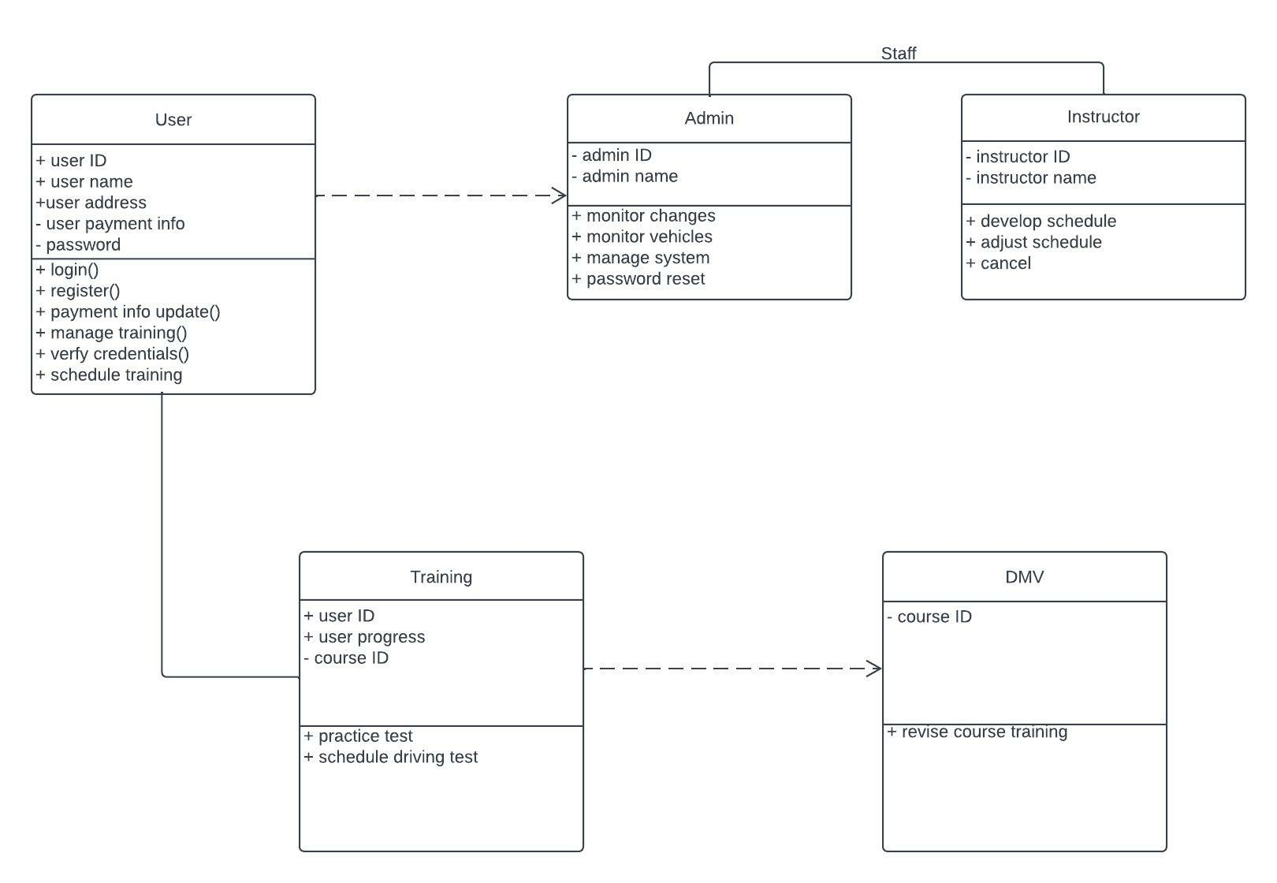

## Technical Requirements

*The program has a few technological needs, including developing an online edition using the cloud and a mobile edition allowing users to view downloaded content on the fly. A cloud-based or physically located database will be necessary to retain the username, password, and other essential information. To maintain data integrity and security, every data that is sent among a user and the system must be encrypted using SSL. There are other methods to shield against brutal force. They are reducing the number of erroneous logins using two-factor authentication. The system would activate two-factor authentication if another IP address was discovered. If the student types in the wrong password three times, the self-serve reset tool will direct them to contact the administrator to retrieve their credentials. Information, namely the training schedule for booking appointments and monitoring a user's training progress, might be updated more quickly if the platform was cloud-based.*